F. EXAMPLE PROJECTS WHICH BEST ILLUSTRATE PROPOSED TEAM’S QUALIFICATIONS FOR THIS CONTRACT  (Present as many projects as requested by the agency, or 10 projects, if not specified. Complete one Section F for each project.) |  |  |  |  |  |  | 20. EXAMPLE PROJECT KEY NUMBER  01
21. TITLE AND LOCATION (CITY AND STATE)  Caltrans District 7, Contract No. 07A5816,  On-Call Roadway Construction Inspection, Construction  Engineering and Scheduling Support Services, Ventura, CA |  |  |  | 22. YEAR COMPLETED
 |  |  |  | PROFESSIONAL SERVICES  Ongoing |  |  | CONSTRUCTION (IF APPLICABLE)
23. PROJECT OWNER’S INFORMATION
a. PROJECT OWNER  Caltrans District 7 |  | b. POINT OF CONTACT NAME  Robert Phan, Caltrans Contract Manager |  |  | c. POINT OF CONTACT TELEPHONE NUMBER  213.793.9281
S2 Engineering provides construction management services to the Caltrans Ventura field office. These services
encompasses a wide range of support for emergencies (DDO), minor, and regular projects, including registered ARE, roadway construction inspection, office engineering, and CPM scheduling. Registered ARE and Office engineering services include managing extra work bills, approving lane closures, falcon filing, ensuring labor compliance, preparing pay estimates, handling contract acceptance, writing order requests, reviewing project schedules, analyzing claims, and coordinating TMC and COZEEP requests and cancellations. Field support services include preparing daily reports, assisting the resident engineer, communicating with contractors, and preparing tentative agreements. These tasks are being carried out for all Caltrans projects within Ventura County. Currently, there are 41 projects, with more being added, totaling an approximate value of $340 million. These projects span across SR-101, SR-23, SR-33, SR-34, SR-118, SR-126, and SR-150, and include the following work:

Construction Management
Construction Inspection
Document control, OE
Traffic Control and Safety
Contract Change Orders
SWPPP / Hazmat
Labor Compliance
Submittals and RFI’s
Project Controls and Contract Administration
Public Coordination
ADA Compliance
Utility Coordination
PROJECT RELEVANCE
- Road paving; Pavement rehabilitation
- Roadway marking and striping
- Traffic and street sign installation
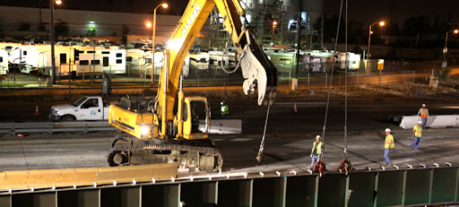
- Electrical / Landscape work related to roadway
- Guardrail, cable rail, and barrier wall
- Storm drains; Slope repairs, geogrids
- Slope Stabilization, including piles, RW, anchored walls
- Traffic Control and management, including COZEEP / TMC
- Coordination with third parties
- Safety Improvements

This comprehensive scope of services ensures the efficient and effective execution of Caltrans projects.

25. FIRMS FROM SECTION C INVOLVED WITH THIS PROJECT
a. | (1) FIRM NAME  S2 Engineering, Inc |  | (2) FIRM LOCATION (CITY AND STATE)  Rancho Cucamonga, CA |  |  | (3) ROLE  Prime: CM, Inspection, OE
b. | AECOM |  | Orange, CA |  |  | Sub: Roadway Inspection
c. | CEI |  | Los Angeles, CA |  |  | Sub: Roadway Inspection
d. | Jacobs |  | Ontario, CA |  |  | Sub: Roadway Inspection
e. | NV5, Inc. |  | Fresno, CA |  |  | Sub: Roadway Inspection
STANDARD FORM 330 (REV. 7/2021)

